# ***Challenge 5: Monitoring with Grafana***

Table of Contents

Set up Grafana on a new compute instance. 1

Install and configure the Oracle Cloud Infrastructure CLI : 1

Create a new Dashboard based on OCI Metrics 4

Create a Query to visualize Data 6

=====================================================================================

## Set up Grafana on a new compute instance.

Install and configure the Oracle Cloud Infrastructure CLI – by download or by YUM install

Configure Group, User and Policy in Oracle Cloud Infrastructure Console

Install Grafana and the OCI Plugin

Configure the Grafana DataSource

Create a new Dashboard with OCI Metrics

## Install and configure the Oracle Cloud Infrastructure CLI :

In this step, the software will be installed an configured. The new created SSH public key has to be added in the OCI console for further actions.

As OS user root we create a new user for OCI actions.

# groupadd oci

# useradd oci -g oci

# passwd oci

After the successful CLI installation, you have to configure it.

$ /home/oci/bin/oci setup config

Add the content of the public key file in the OCI console to your user which you want to work with

Test the CLI configuration – example to list all compartments in your tenant.

$ /home/oci/bin/oci iam compartment list --all | grep name

"name": "ManagedCompartmentForPaaS",

"name": "Challenge5",

===

Install Grafana and the OCI Plugin :

===

Login as user root and install Grafana.

# wget https://dl.grafana.com/oss/release/grafana-6.3.6-1.x86_64.rpm

# yum localinstall grafana-6.3.6-1.x86_64.rpm

Enable auto start and start the Grafana server manually.

# systemctl enable grafana-server.service

# systemctl daemon-reload

# systemctl start grafana-server

Enable port 3000 (Grafana default port in firewall – the port can be changed in /etc/grafana/grafana.ini) to provide web access to Grafana.

# firewall-cmd --permanent --zone=public --add-port=3000/tcp

# firewall-cmd --reload

# firewall-cmd --permanent --zone=public --list-ports

3000/tcp

Install the Grafana Oracle Cloud Infrastructure oci-datasource plugin.

# grafana-cli plugins install oci-datasource

# service grafana-server restart

Verify the Grafana plugin directory with the installed plugin.

# ls -la /var/lib/grafana/plugins

Grafana needs the configuration file and the SSH Key from the user oci.

As user root, copy the files and set the ownership to OS user grafana.

# cp -r /home/oci/.oci /usr/share/grafana

# chown -R grafana:grafana /usr/share/grafana/.oci

Change the path to the key file in /usr/share/grafana/.oci/config.

# vi /usr/share/grafana/.oci/config

From:

key_file=/home/oci/.oci/oci_api_key.pem

To:

key_file=/home/oci/.oci/oci_api_key.pem

## Create a new Dashboard based on OCI Metrics

Open your browser and log in into Grafana with [SERVERNAME]:3000.

Username and password are *admin/admin*.

NOTE : You have to change your initial password immediately.



Add Data source : 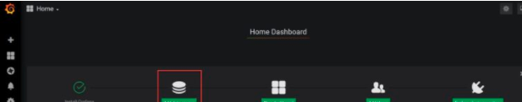

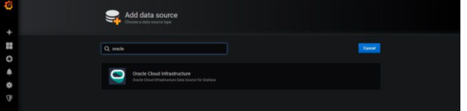

Configure the Data Source

Fill in your tenancy OCI, region and set Environment = Local.

Test the connection.

For troubleshooting see Grafana logfile in directory /var/log/grafana.

If your default region like ZRH / EU-ZURICH-1 is not listed, then you have to edit the a plugin file as described below. Otherweise no metrics are shown.

In my case : Example to use Grafana for the Datacenter eu-zurich-1:

Edit the file /var/lib/grafana/plugins/oci-datasource/dist/constants.js and add your missed region – restart Grafana.

_export('regions', regions = ['ca-toronto-1', 'eu-frankfurt-1', 'uk-london-1', 'us-ashburn-1', 'us-phoenix-1','eu-zurich-1']);

Create a new dashboard & Add a query :

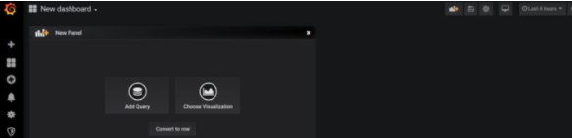

## Create a Query to visualize Data

In this dashboard , I used the*region eu-zurich-1***,***my compartment***,** the *namespace oci_autonomous_database*and the *metric CpuUtilization*.

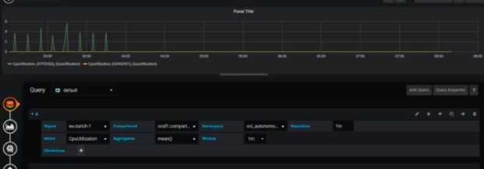

Other metrics available like:

* CurrentLogons
* ExecutionCount
* Sessions
* StorageUtilization (in %)

Here’s the final dashboard:

Dashboard displays the overall health of a hosted Grafana instance:

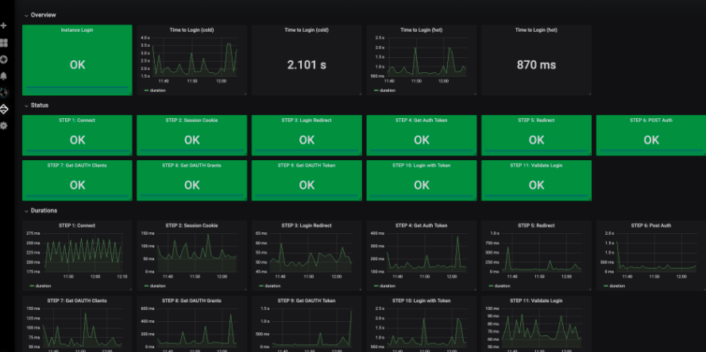

You have several optional parameters to customize the query and time range. With compartmentId, use any combination of other parameters. For example, to select a specific namespace and custom query, use the following format:

echo ’{"compartmentId":"ocid1.compartment.oc1..aaaaxxxxxxx", "namespace":"<your namespace>", "query":"<your query>"}’ | fn invoke metrics-export-app oci-monitoring-metric-export

## Dashboard import and export

dashboard in Grafana is JSON based.

